Road Traffic Vehicle Detection and Tracking using Deep Learning with Custom-Collected and Public Datasets

Deep Learning algorithms gaining popularity almost in all fields such as health care to predict patient disease condition, road traffic monitoring etc. To monitor traffic or to detect vehicle YOLOV4 has achieved highest vehicle detection rate but sometime this algorithm will give false detection rate and to overcome from this problem author of this paper adding DeepSort algorithm which will track actual presence of vehicles from video frame predicted by YOLOV4 so the false prediction perform by YOLOV4 can be avoid by using DeepSort algorithm.

YOLOV4 and DeepSort get trained on 3 different datasets such as COCO, Berkeley and Dash Cam dataset. Author has experiment with this models by using real road traffic data obtained from Dash Cam but we don’t have such dataset so we are using traffic video from Youtube.

In propose paper video will be input to application and then application will extract frame from videos and give input to YOLOV4 for vehicle detection and detected vehicle frame will be further analysed by DeepSort algorithm to track vehicle and if vehicle tracked then DeepSort will put bounding box across tracked vehicle and increment the tracking count.

Author trained this model on GPU laptop and we don’t have such laptop wo we converted model to CPU laptop so it will run little slow

To implement this project we have designed following modules

1. Generate & Load YOLOv4-DeepSort Model: using this module we will generate and load YOLOV$-DeepSort model
2. Upload Video & Detect Car & Truck: using this module we will upload test video and then apply YOLOV4 to detect vehicle and this detected vehicle frame will be further analyse by DeepSort to track real vehicles

In below screen we are showing code to load YOLO and Deep sort models

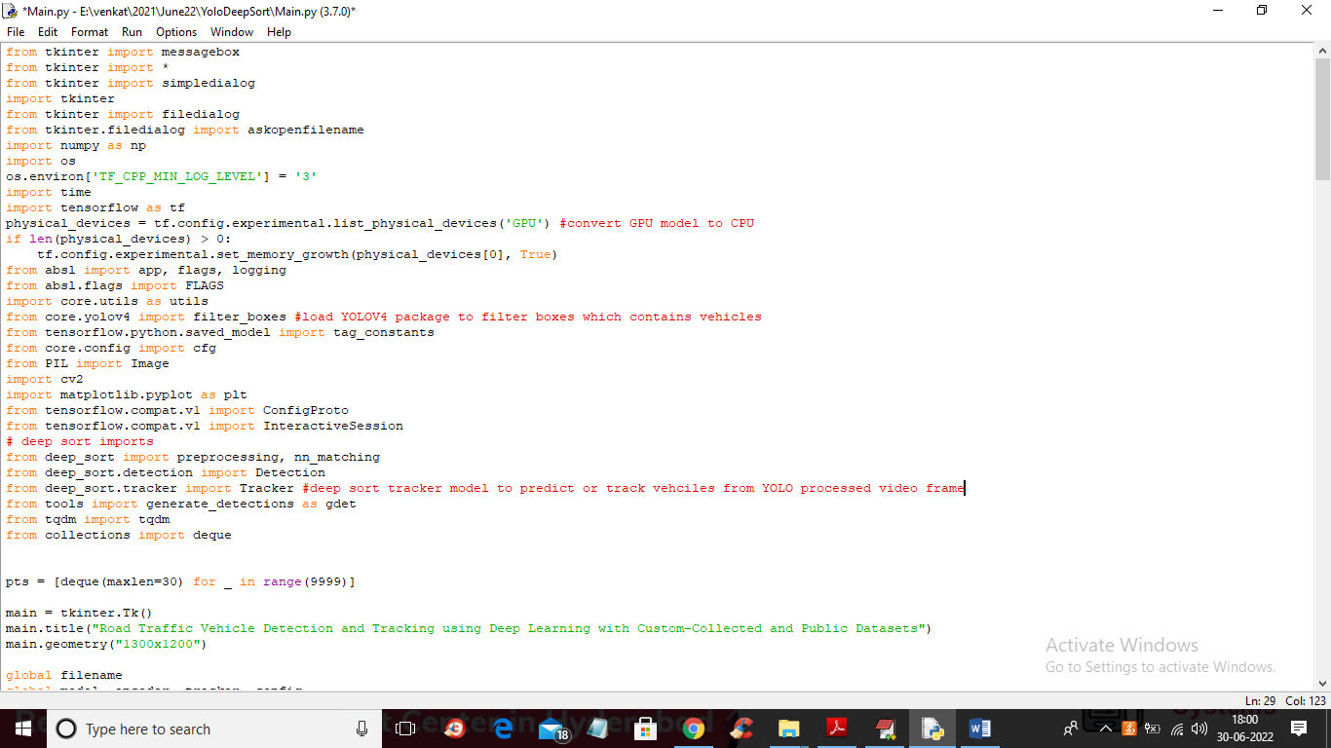

In above screen read red colour comments to know about YOLO and DeepSort packages and classes.

SCREEN SHOTS

To run project double click on ‘run.bat’ file to get below screen

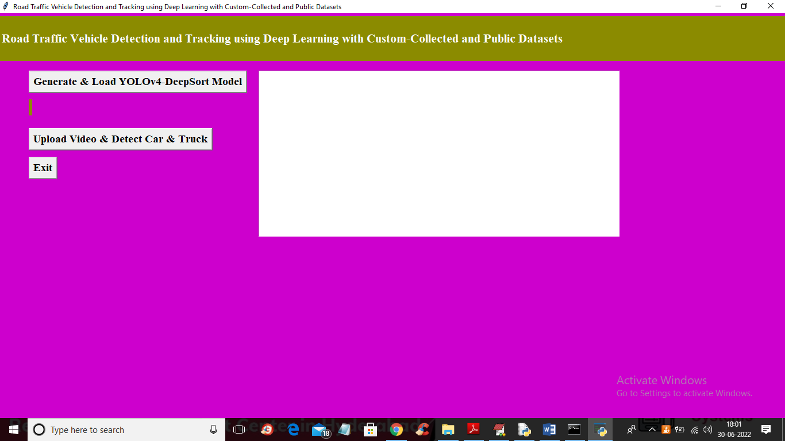

In above screen click on ‘Generate & Load YOLOv4-DeepSort Model’ button to load model and get below output

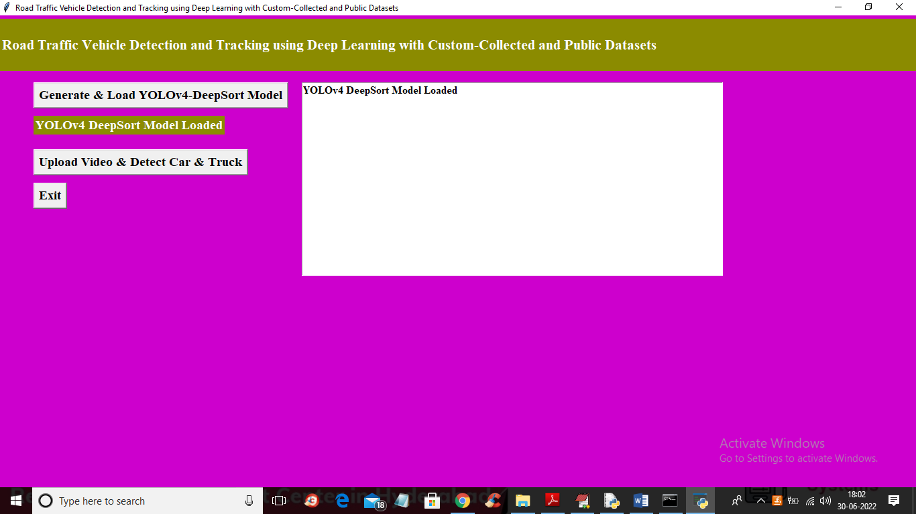

In above screen model is loaded and now click on ‘Upload Video & Detect Car & Truck’ button to upload video and start detecting and tracking vehicles

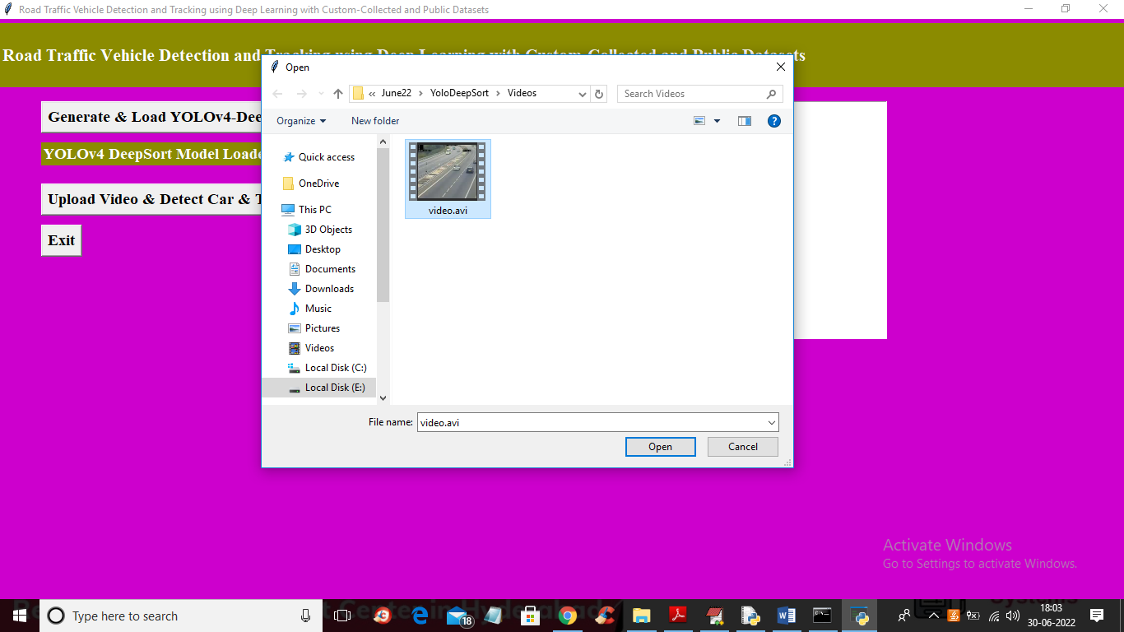

In above screen selecting and uploading ‘traffic video’ file and then click on ‘Open’ button to get below output. To get output u need to wait for few seconds

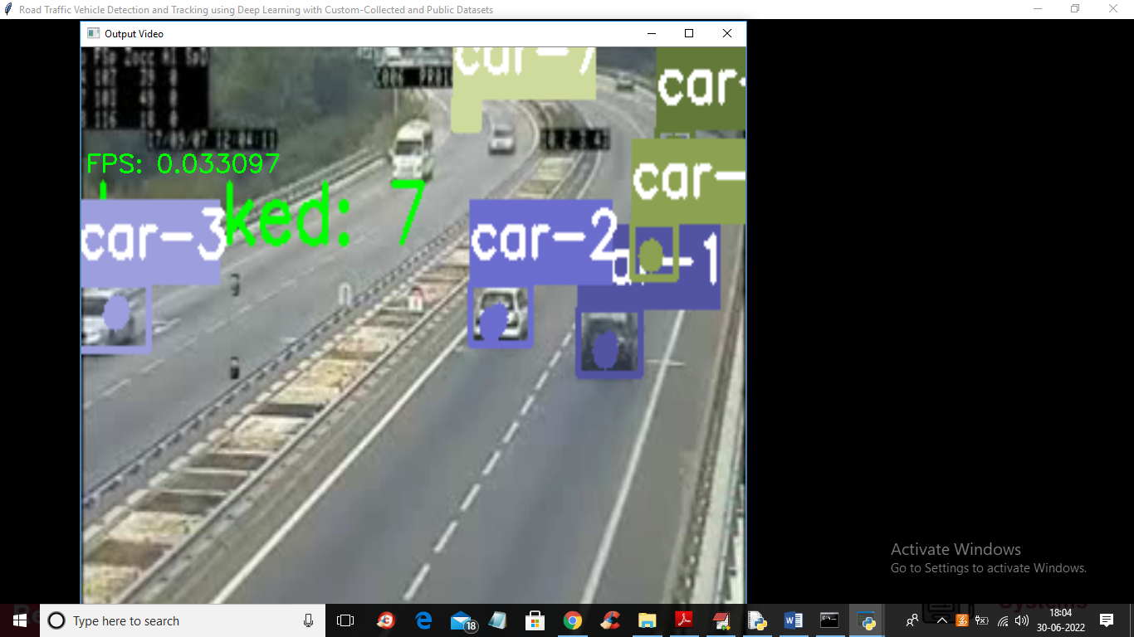

In above screen video will play slowly and then YOLOV4 and DeepSort will start detecting and tracking cars and trucks and in green colour we can see number of real tracked cars

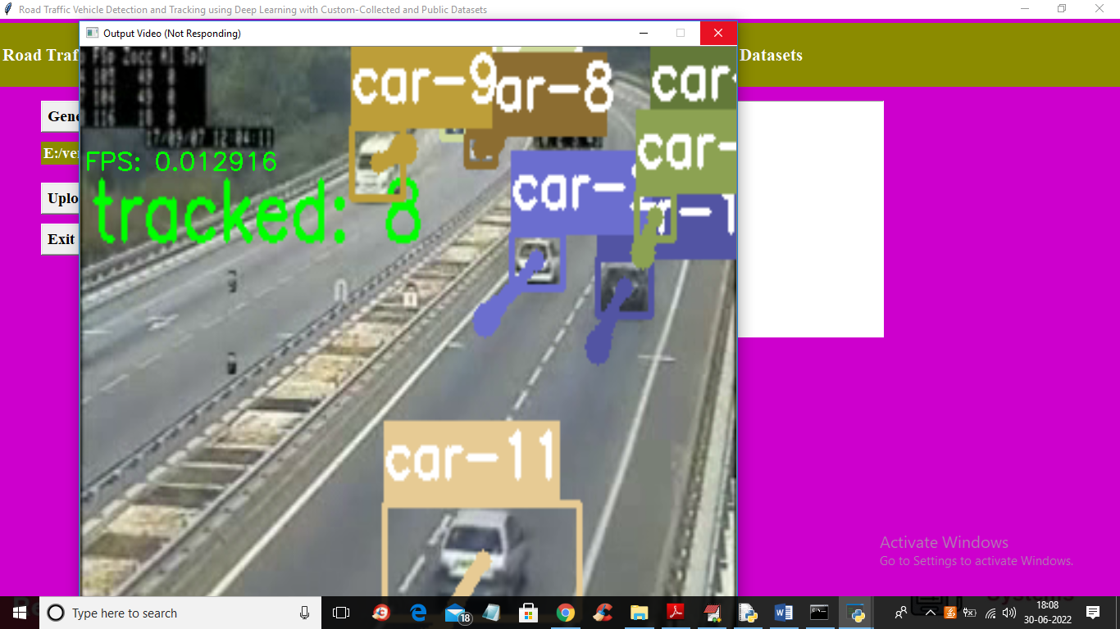

In above screen FPS refer to ‘Frame Per Second’ and application will track vehicles till the end of the video

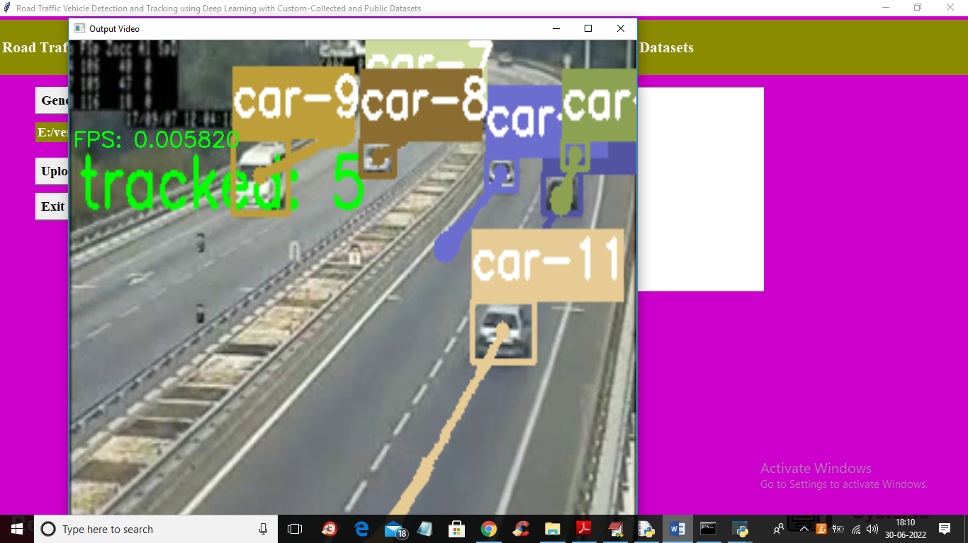

Similarly you can upload any video and track vehicles

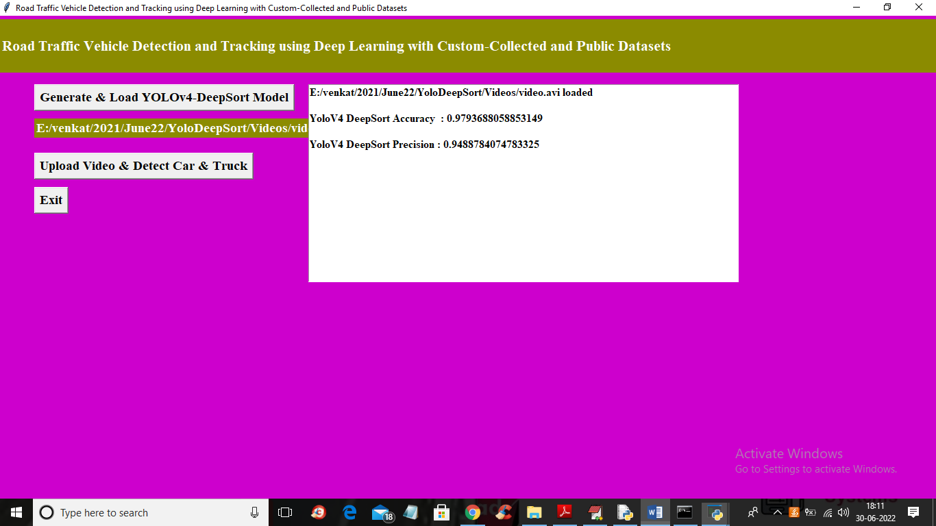

In above screen we can accuracy and precision of propose YOLOV4-DeepSort model